

Q1:

Software Requirements Specification

for

<FOOD ORDERING SYSTEM>
Version 1.0 approved
Prepared by
<TRẦN HOÀNG PHÚC>
<FPT University Đà Nẵng>
<9-10-2024>

Q2:
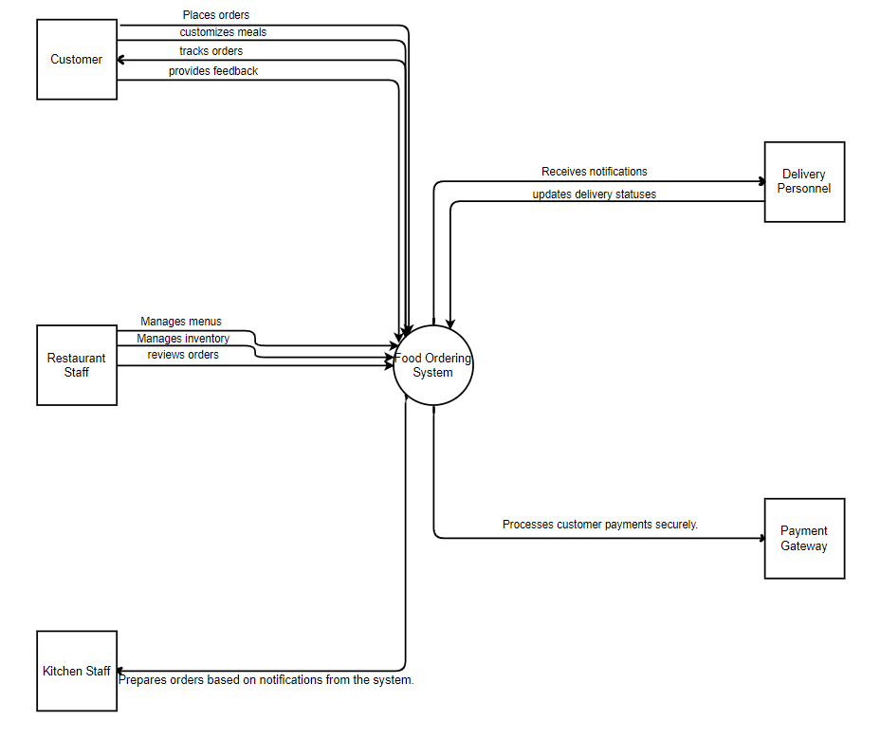Notes:
- Draw the correct syntax to describe the context diagram (0.4 point)
- Draw external entities (0.6 point)
- Draw the data flows described in this exam paper (1.5 points)
>

Q3:
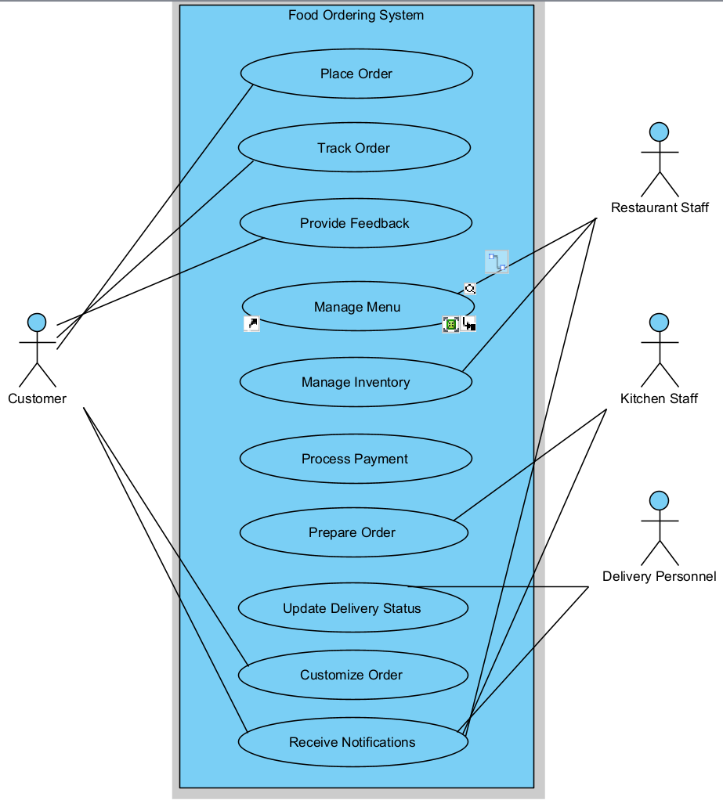Notes:
- Draw the correct syntax to describe the use case diagram (0.4 point)
- Draw actors and brief descriptions (0.9 point)
- Draw use cases and brief descriptions (2.7 points)
>

# | Actor | Description
01 | Customer | Places orders, customizes orders, tracks orders, provides feedback, and receives notifications.
02 | Restaurant Staff | Manages menu, manages inventory, processes orders, and receives notifications.
03 | Delivery Personnel | Updates delivery status and receives notifications.
04 | Kitchen Staff | Prepares orders based on notifications from the system and updates order status.
05 | Payment  Gateway | Processes customer payments securely (special actor not show in the diagrams)

# | Use Case | Actors | Description
UC-01 | Place Order | Customers | Allows customers to select items and submit an order.
UC-02 | Customize Order | Customers | Enables customers to modify their orders according to preferences or dietary requirements.
UC-03 | Track Order | Customers | Enables customers to monitor the status of their order in real-time.
UC-04 | Provide Feedback | Customers | Allows customers to give feedback on their order and experience.
UC-05 | Manage Menu | Restaurant Staff | Enables restaurant staff to update menu items and prices.
UC-06 | Manage Inventory | Restaurant Staff | Allows restaurant staff to track and update inventory levels.
UC-07 | Process Payment | Payment  Gateway | Handles secure transaction processing for orders.
UC-08 | Prepare Order | Kitchen Staff | Notifies kitchen staff of new orders and allows them to update order status during preparation.
UC-09 | Update Delivery Status | Delivery Personnel | Allows delivery personnel to provide real-time updates on order delivery.
UC-10 | Receive Notifications | Customer, Restaurant Staff, Kitchen Staff, Delivery Personnel | Sends relevant notifications to all actors

Q4:
Business rule:
- All customer orders must be processed through the Food Ordering System before being sent to the kitchen staff for preparation.
- Restaurant staff must update both the menu and inventory information in the system to ensure accurate order processing and customization options.
- Kitchen staff must update the order status in the system as they progress through preparation stages.
- Customers can customize their orders within the options provided by the restaurant's menu and inventory.
- Delivery personnel must update delivery statuses in real-time for orders assigned to them by the system.
Notes:
- Describe 4 business rules (1.0 point)
- For each incorrect business rule, 0.25 points will be deducted
>
ID | Rule Definition | Use cases
BR-01 | All customer orders must be processed through the Food Ordering System before being sent to the kitchen staff for preparation. | UC-01, UC-02, UC-03
BR-02 | Restaurant staff must update both the menu and inventory information in the system to ensure accurate order processing and customization options. | UC-05,UC-06
BR-03 | Kitchen staff must update the order status in the system as they progress through preparation stages. | UC-08
BR-04 | Customers can customize their orders within the options provided by the restaurant's menu and inventory. | UC-02
BR-05 | Delivery personnel must update delivery statuses in real-time for orders assigned to them by the system. | UC-09

Q5:
< Student must replace this line
Notes:
- Draw the correct syntax to describe the state transition diagram (0.3 point)
- Draw states and brief descriptions (0.9 point)
- Draw transitions (0.8 points)
>
<Student must replace this line, answer Q5 by drawing 1 state transition diagram that reflect this exam paper and copy and then paste the image of that state transition diagram here >

< Student must replace this line, briefly describe the states of the diagram by fill the content to below table>
# | State | Description
01 | Accepted | The Requester submitted a completed chemical request and the system accepted it for processing.
02
03

